DOCKER CHALLENGE 01

Create a customized Docker image using a Dockerfile.
#vi Dockerfile createa docker file customized images
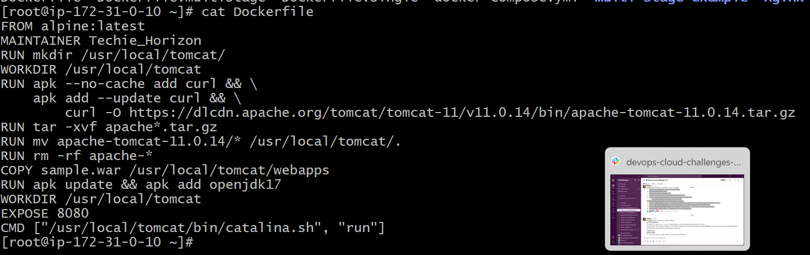
#docker buildx build -f Dockerfile -t mohdparvez23/my_app:3.0
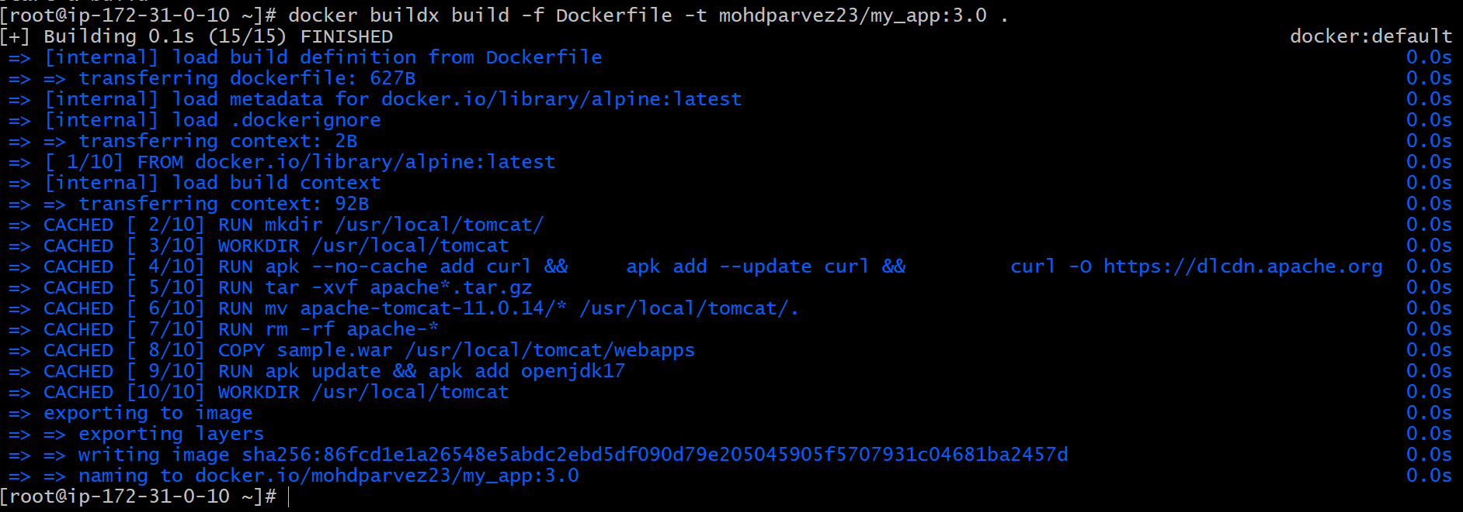

Push the image to Docker Hub.
Add tag #docker tag new_image:tag mohdparvez23/my_app:3.0
Now push the image to docker hub #docker push mohdparvez23/my_app:3.0
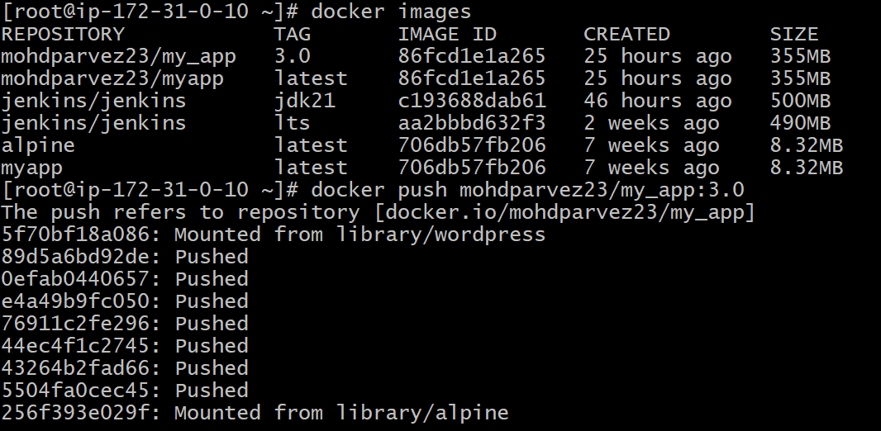
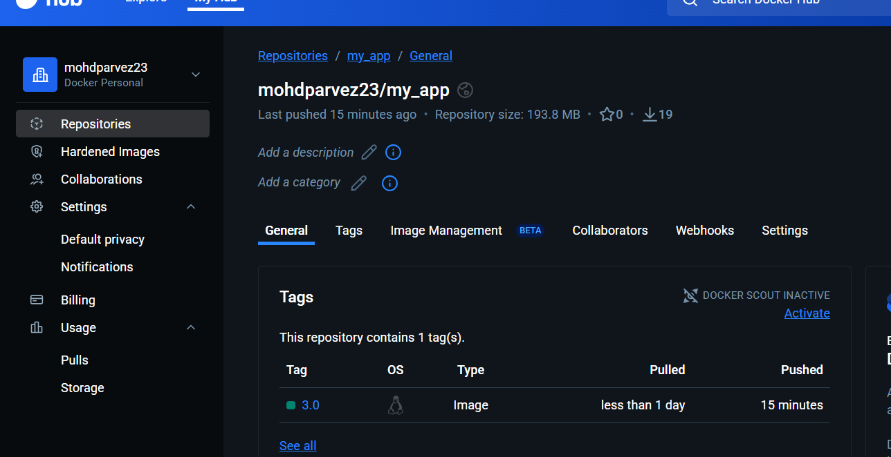

Push the same image to Amazon ECR.
Create the repository in aws ecr
#aws ecr create-repository --repository-name my_app
Add the tag and login
# aws ecr get-login-password --region us-east-1 | docker login --username AWS --password-stdin 056000095785.dkr.ecr.us-east-1.amazonaws.com
#docker tag my_app:latest 056000095785.dkr.ecr.us-east1.amazonaws.com/my_app:latest

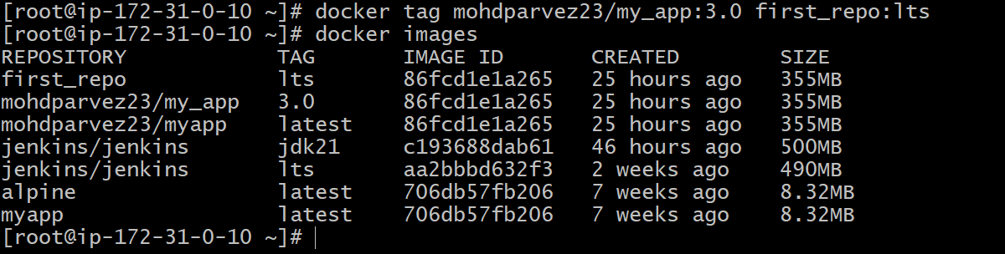
Now push the image to the ecr
#docker push 056000095785.dkr.ecr.us-east-1.amazonaws.com/my_app:3.0
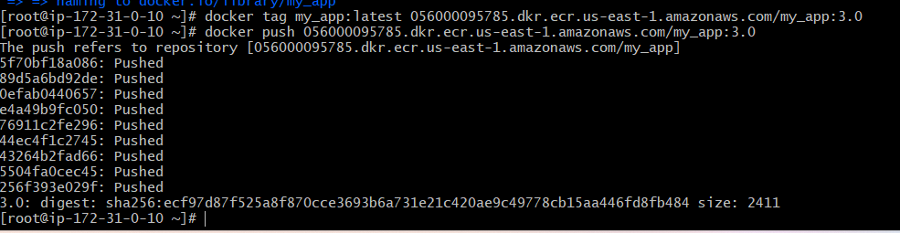
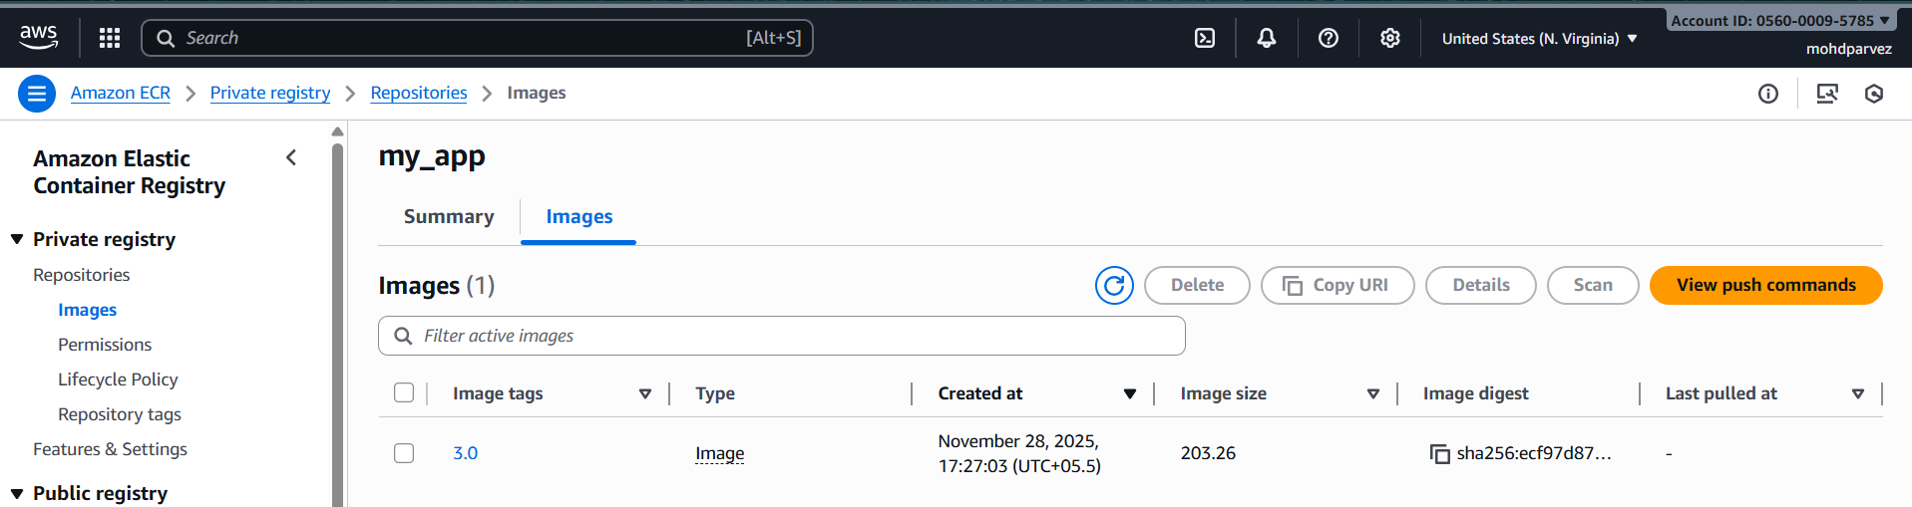

Provision one EC2 instance using Terraform and install Jenkins.
- provider "aws" {
- region = "us-east-1"
- }

- resource "aws_instance" "jenkins" {
- ami = "ami-0fa3fe0fa7920f68e" # Amazon Linux 2
- instance_type = "t3.large"
- key_name = "my-key"
- subnet_id = "subnet-0491ca8b1885b7e5e"

- root_block_device {
- volume_size = 10
- volume_type = "gp3"
- }

- user_data = <<-EOF
- #!/bin/bash
- set -e

- yum update -y

- # Install Java (Jenkins requirement)
- amazon-linux-extras enable java-openjdk17
- yum install -y java-17-openjdk

- # Add Jenkins repo and key
- wget -O /etc/yum.repos.d/jenkins.repo https://pkg.jenkins.io/redhat/jenkins.repo
- rpm --import https://pkg.jenkins.io/redhat/jenkins.io-2023.key

- # Install Jenkins
- yum install -y jenkins

- # Enable and start Jenkins
- systemctl enable jenkins
- systemctl start jenkins
- EOF

- tags = {
- Name = "jenkins"
- }
- }

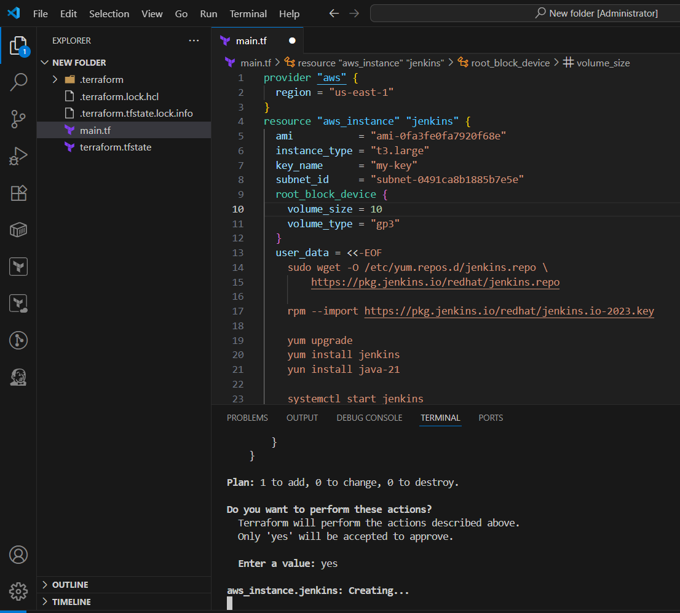
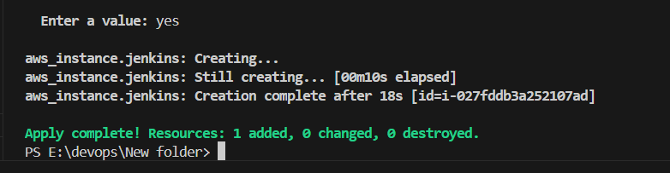
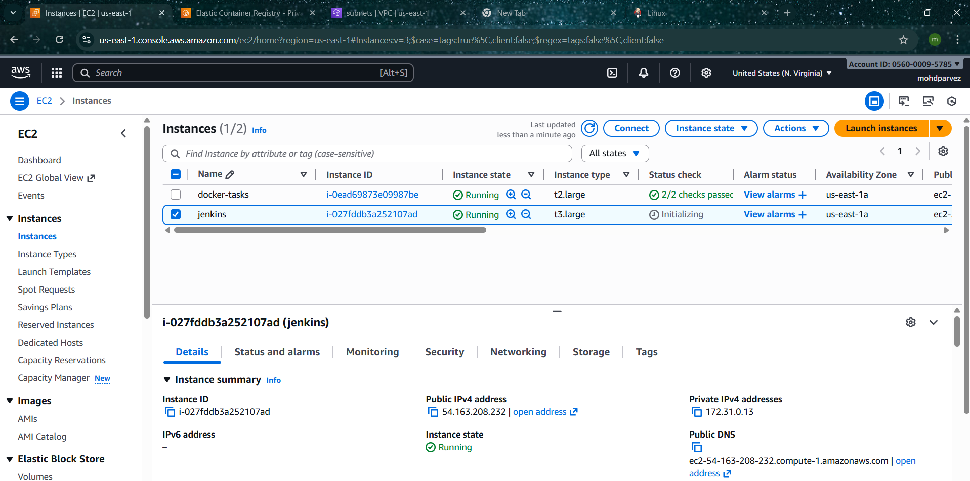

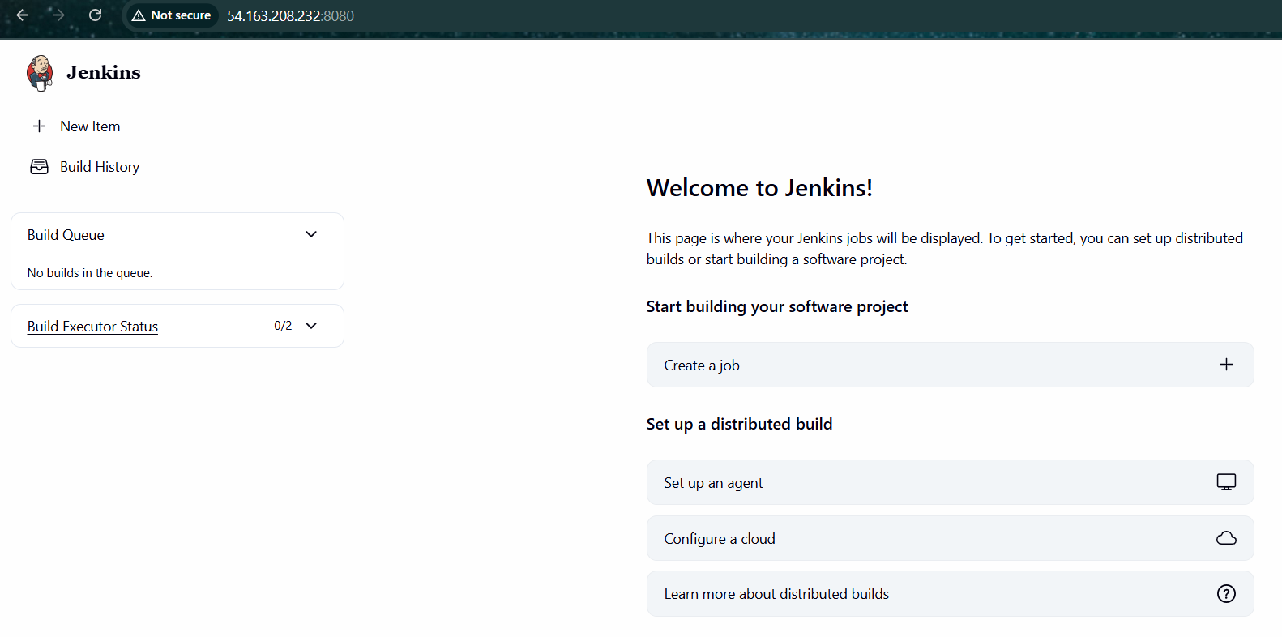

5. Create one Jenkins job to build and push the Docker image to Docker Hub.Source: https://github.com/betawins/Python-app.git: open_file_folder Source Codes: https://github.com/betawins/docker-tasks.git

From the frontend source code, write a Dockerfile, build a Docker image, run it, and push that image to your Docker registry.

From the Java-based source code, write a Dockerfile, build, run, and push the image to the Docker registry.

From the Node.js-based source code, write a Dockerfile, build with tag v1, run, and push it to the Docker registry.

Write a docker-compose file to set up WordPress with a MySQL database.

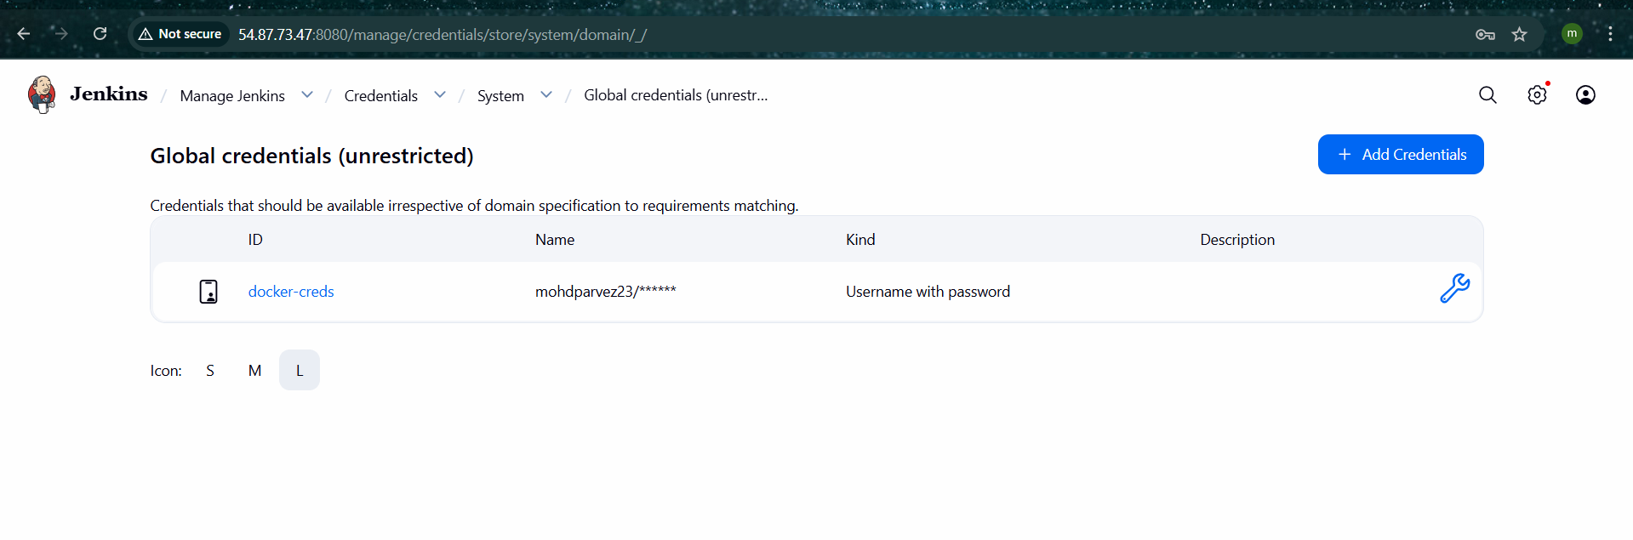
pipeline {
agent any

environment {
DOCKERHUB_CREDENTIALS = 'dockerhub' // Jenkins credentials ID
DOCKERHUB_REPO = 'mohdparvez23' // Docker Hub username
}

stages {
stage('Verify Docker') {
steps {
sh 'docker --version'
}
}
stage('Clean Workspace') {
steps {
cleanWs()
}
}

// 🐍 PYTHON IMAGE
stage('Build & Push Python Image') {
steps {
git url: 'https://github.com/betawins/Python-app.git', branch: 'main'

writeFile file: 'Dockerfile', text: '''
FROM python:3.9-slim
WORKDIR /app
COPY . .
RUN pip install -r requirements.txt
CMD ["python", "app.py"]
'''

withCredentials([usernamePassword(
credentialsId: DOCKERHUB_CREDENTIALS,
usernameVariable: 'DOCKER_USER',
passwordVariable: 'DOCKER_PASS'
)]) {
sh '''
docker build -t ${DOCKERHUB_REPO}/python-app:latest .
echo "$DOCKER_PASS" | docker login -u "$DOCKER_USER" --password-stdin
docker push ${DOCKERHUB_REPO}/python-app:latest
'''
}
}
}

// ☕ JAVA IMAGE
stage('Build & Push Java Image') {
steps {
dir('java-app') {
writeFile file: 'App.java', text: '''
public class App {
public static void main(String[] args) {
System.out.println("Hello from Java App");
}
}
'''
writeFile file: 'Dockerfile', text: '''
FROM eclipse-temurin:17-jdk
WORKDIR /app
COPY . .
RUN javac App.java
CMD ["java", "App"]
'''
}

withCredentials([usernamePassword(
credentialsId: DOCKERHUB_CREDENTIALS,
usernameVariable: 'DOCKER_USER',
passwordVariable: 'DOCKER_PASS'
)]) {
sh '''
docker build -t ${DOCKERHUB_REPO}/java-app:latest java-app
echo "$DOCKER_PASS" | docker login -u "$DOCKER_USER" --password-stdin
docker push ${DOCKERHUB_REPO}/java-app:latest
'''
}
}
}

// 🟢 NODE IMAGE
stage('Build & Push Node Image') {
steps {
dir('node-app') {
writeFile file: 'package.json', text: '''
{
"name": "node-app",
"version": "1.0.0",
"scripts": { "start": "node index.js" }
}
'''
writeFile file: 'index.js', text: '''
require("http")
.createServer((req, res) => res.end("Hello Node"))
.listen(3000);
'''
writeFile file: 'Dockerfile', text: '''
FROM node:14
WORKDIR /app
COPY package.json .
RUN npm install
COPY . .
EXPOSE 3000
CMD ["npm", "start"]
'''
}

withCredentials([usernamePassword(
credentialsId: DOCKERHUB_CREDENTIALS,
usernameVariable: 'DOCKER_USER',
passwordVariable: 'DOCKER_PASS'
)]) {
sh '''
docker build -t ${DOCKERHUB_REPO}/node-app:v1 node-app
echo "$DOCKER_PASS" | docker login -u "$DOCKER_USER" --password-stdin
docker push ${DOCKERHUB_REPO}/node-app:v1
'''
}
}
}
}
}
